NAME: SIVARANJANII.M
DATE:26.08.25 ROLL NO.:241901109

EXERCISE 5
AIM:
To develop a simple XML-RPC client-server application in Python that performs basic arithmetic operations (addition, subtraction, multiplication, and division) remotely.
ALGORITHM:
SERVER:
- Import SimpleXMLRPCServer.
- Define functions: add, subtract, multiply, and divide.
- Create an XML-RPC server on "localhost" and port 8000.
- Register the arithmetic functions with the server.
- Run the server using serve_forever ().
CLIENT:
- Import xmlrpc.client and create a ServerProxy to connect to the server.
- Get two numbers from the user.
- Ask the user to choose an operation (add, subtract, multiply, divide).
- Call the corresponding remote function on the server using the proxy.
- Display the result returned from the server.

CODE:
SERVER:
from xmlrpc.server import SimpleXMLRPCServer
def add(x, y):
return x + y
def subtract(x, y):
return x - y
def multiply(x, y):
return x * y
def divide(x, y):
if y == 0:
return "Error: Division by zero"
return x / y
server = SimpleXMLRPCServer(("localhost", 8000))
print("XML-RPC Server is listening on port 8000...")
server.register_function(add, "add")
server.register_function(subtract, "subtract")
server.register_function(multiply, "multiply")
server.register_function(divide, "divide")
server.serve_forever()

CLIENT:
import xmlrpc.client
proxy = xmlrpc.client.ServerProxy("http://localhost:8000/")
def get_number(prompt):
while True:
try:
return float(input(prompt))
except ValueError:
print("Please enter a valid number.")
def get_operation():
operations = {"add", "subtract", "multiply", "divide"}
while True:
op = input("Enter operation (add, subtract, multiply, divide): ").strip().lower()
if op in operations:
return op
print("Invalid operation. Try again.")
def main():
print("Simple XML-RPC Calculator")
x = get_number("Enter first number: ")
y = get_number("Enter second number: ")
op = get_operation()
try:
result = getattr(proxy, op)(x, y)
print(f"Result of {op}({x}, {y}) = {result}")
except Exception as e:
print("Error:", e)
if __name__ == "__main__":
main()

OUTPUT:
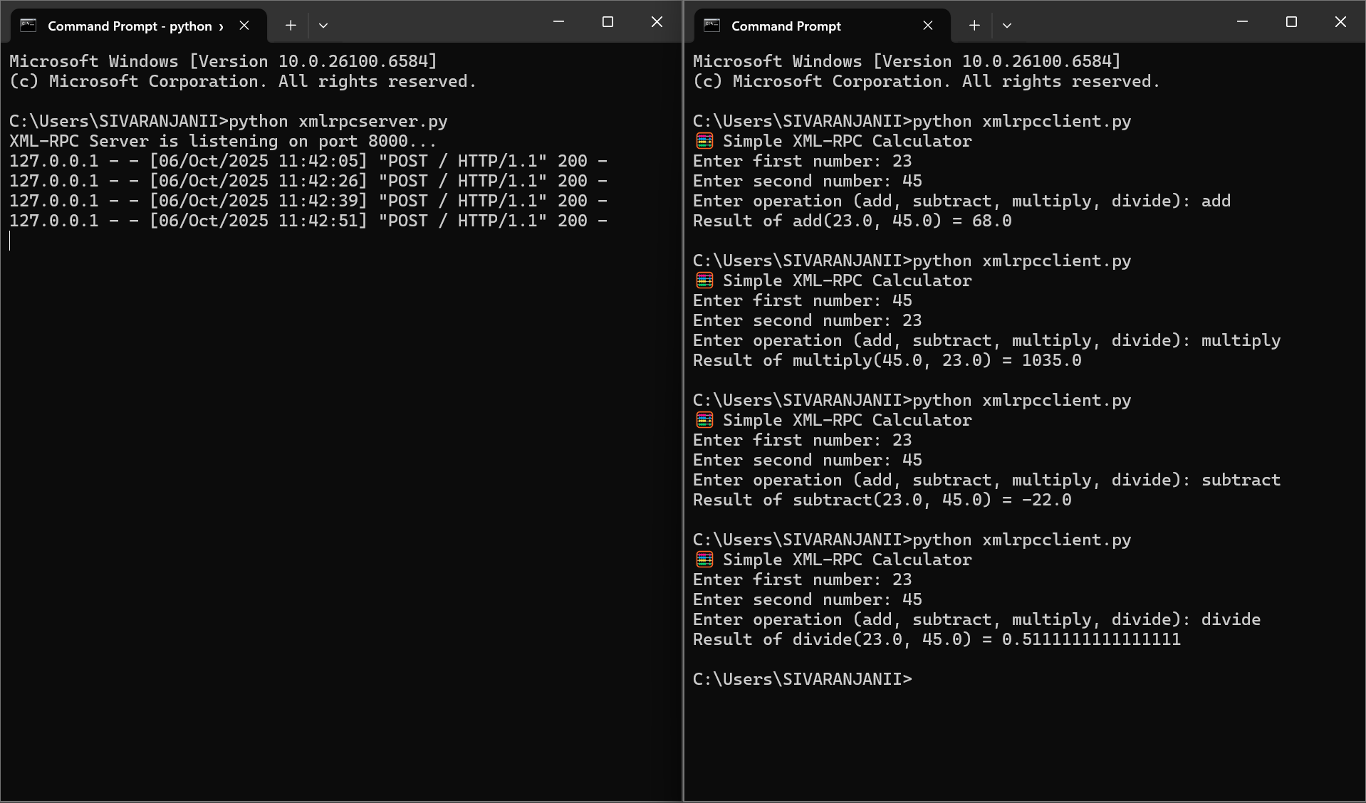

RESULT:
The program successfully implements an XML-RPC-based calculator, where the server provides arithmetic operations and the client performs remote function calls to compute results.

